**Supplemental Table 1:** Field information from sampling sites and geochemical data. File name: SupplementalTable1_Field,Mineralogical,ElementalData.xlsx

|  |  |  |  |  |  |  |  |  |  |  |  |  |  |  |  |
| --- | --- | --- | --- | --- | --- | --- | --- | --- | --- | --- | --- | --- | --- | --- | --- |
| **Site ID** | **DNA Yield (ng/g sample)** | | | | | **Total ASVs (bacterial primers)** | | | | | **Total ASVs (archaeal primers)** | | | | |
| **G1** | **G2** | **G3** | **G4** | **G5** | **G1** | **G2** | **G3** | **G4** | **G5** | **G1** | **G2** | **G3** | **G4** | **G5** |
| **12B** | 12840 | 2528 |  | 2192 | 50.4 | 65053 | 67854 |  | 106198 | - | - | - |  | - | 73436 |
| **67B** | 5120 | 182.4 |  |  | 100 | 85544 | 84097 |  |  | - | - | - |  |  | - |
| **29** | 801.6 | 2312 | 0.436 |  |  | 89366 | 105104 | 30302 |  |  | 40238 | 44315 | - |  |  |
| **33** | 94.4 | 16000 |  |  | 224 | 107635 | 68446 |  |  | 66105 | 56410 | 54253 |  |  | 49224 |
| **35** | 449.6 |  | 7852 |  |  | 96715 |  | 74831 |  |  | 54148 |  | - |  |  |
| 2256 | 109756 | 49935 |
| **56** | 816 | 4720 | 949.6 | 252.8 |  | 92117 | 100904 | 95481 | 68563 |  | - | 39666 | - | - |  |
| **41** | 1026.4 | 1258 |  |  |  | 84040 | 81330 |  |  |  | 41365 | - |  |  |  |
| **46** | 2696 | 12600 |  |  |  | 85504 | 80565 |  |  |  | - | 49916 |  |  |  |
| (-) indicates a sample which failed sequencing | | | | | | | | | | | | | | | |

**Supplemental Table 2:** DNA yields and ASV counts for each sample.

|  |  |  |
| --- | --- | --- |
|  | Bacterial Dataset | Archaeal Dataset |
| 12B-1 | 0.9637356 | - |
| 12B-2 | 0.9370023 | - |
| 12B-3 | 0.9768435 | - |
| 12B-4 | - | 0.9505377 |
| 67B-1 | 0.9691345 | - |
| 67B-2 | 0.9824577 | - |
| 29-1 | 0.9822437 | 0.9878397 |
| 29-2 | 0.9799543 | 0.9883126 |
| 29-3 | 0.9873348 | - |
| 33-1 | 0.9693695 | 0.9701907 |
| 33-2 | 0.9843773 | 0.9877309 |
| 33-3 | 0.9883092 | 0.9840068 |
| 35-1 | 0.9729288 | 0.9734849 |
| 35-2 | 0.9876492 | - |
| 35-3 | 0.9876442 | 0.9875751 |
| 56-1 | 0.9852115 | - |
| 56-2 | 0.9805659 | 0.9878431 |
| 56-3 | 0.9877158 | - |
| 56-4 | 0.9872632 | - |
| 41-1 | 0.9831951 | 0.9886681 |
| 41-2 | 0.9811539 | - |
| 46-1 | 0.9550911 | - |
| 46-2 | 0.9829102 | 0.9926546 |

**Supplemental Table 3:** Simpson’s diversity index values for each sample in each dataset.

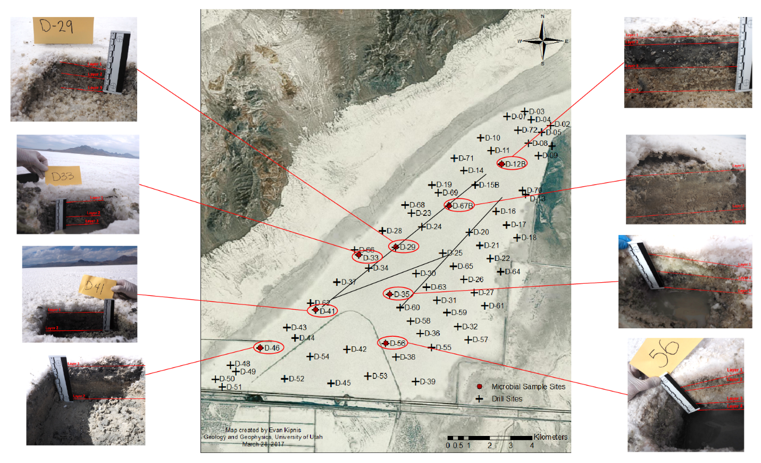

**Supplemental Figure 1:** Sampling locations and field photos of sampling sites. Black lines indicate approximate location of the racetrack at the time of sampling.

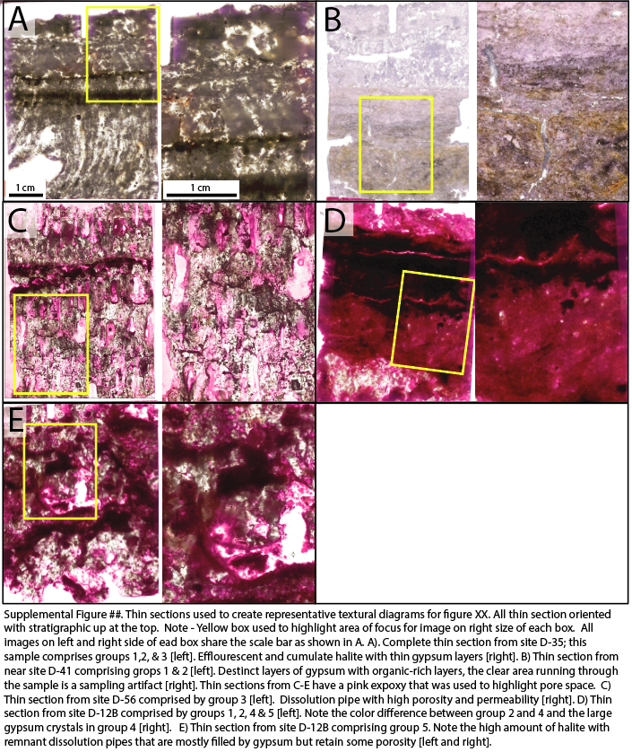

**Supplemental Figure 2:** Thin sections used to create representative textural diagrams for Figure 1. All thin section oriented with stratigraphic up at the top. Note yellow box used to highlight area of focus for image on right side of each box. All images on left and right side of each box share the scale bar as shown in A. A). Complete thin section from site D-35; this sample comprises groups 1,2, & 3 (left). Efflorescent and cumulate halite with thin gypsum layers (right). B) Thin section from near site D-41 comprising groups 1 & 2 (left). Distinct layers of gypsum with organic-rich layers, the clear area running through the sample is a sampling artifact (right). Thin sections from C-E have a pink epoxy that was used to highlight pore space. C) Thin section from site D-56 comprised by group 3 (left). Dissolution pipe with high porosity and permeability (right). D) Thin section from site D-12B comprised by groups 1, 2, 4 & 5 (left). Note the color difference between group 2 and 4 and the large gypsum crystals in group 4 (right). E) Thin section from site D-12B comprising group 5. Note the high amount of halite with remnant dissolution pipes that are mostly filled by gypsum but retain some porosity (left and right).

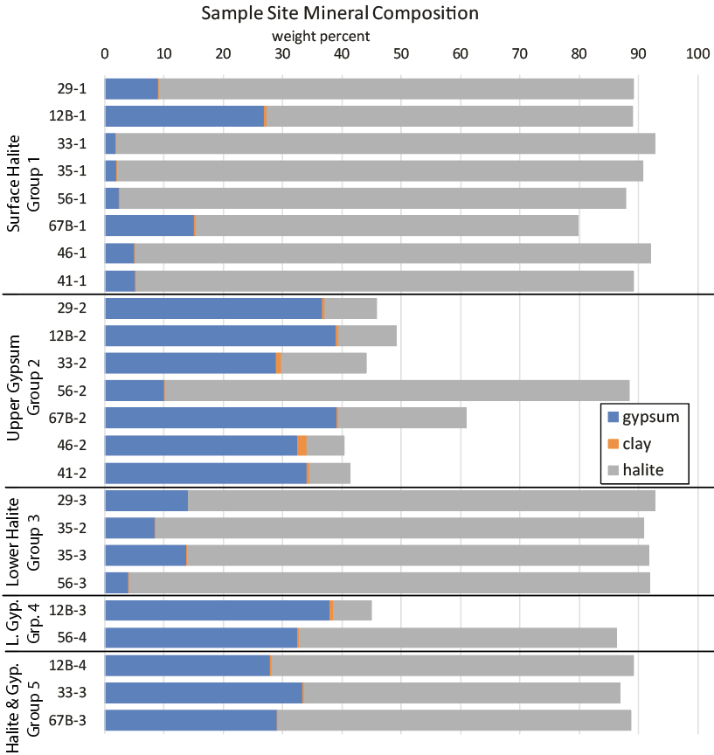

**Supplemental Figure 3:** Mineralogical composition at sample sites as determined from elemental concentrations as weight percent. Samples below 100 percent may be due to waters within sample material*.*

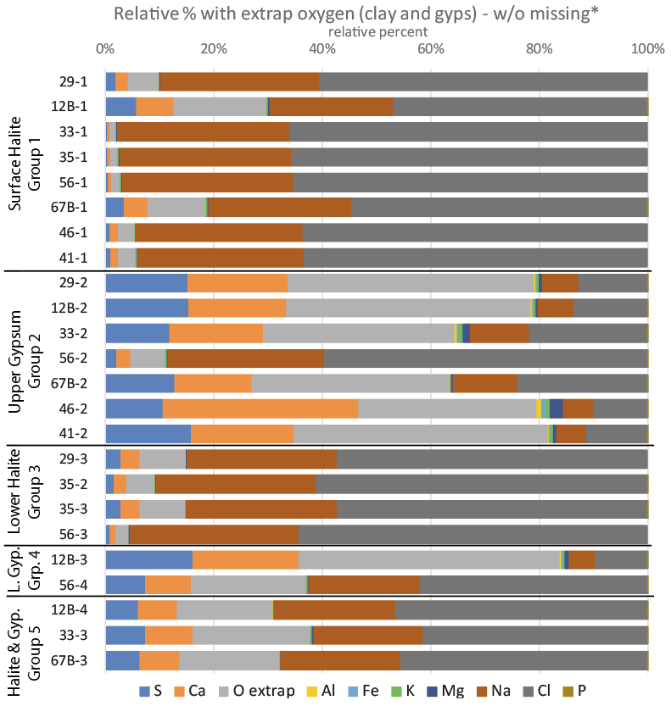

**Supplemental Figure 4:** Elemental data for each sample site and group reported as relative mol percent for the whole sample. Oxygen values were extrapolated from expected components of gypsum (CaSO4*2H2O) and clay minerals.

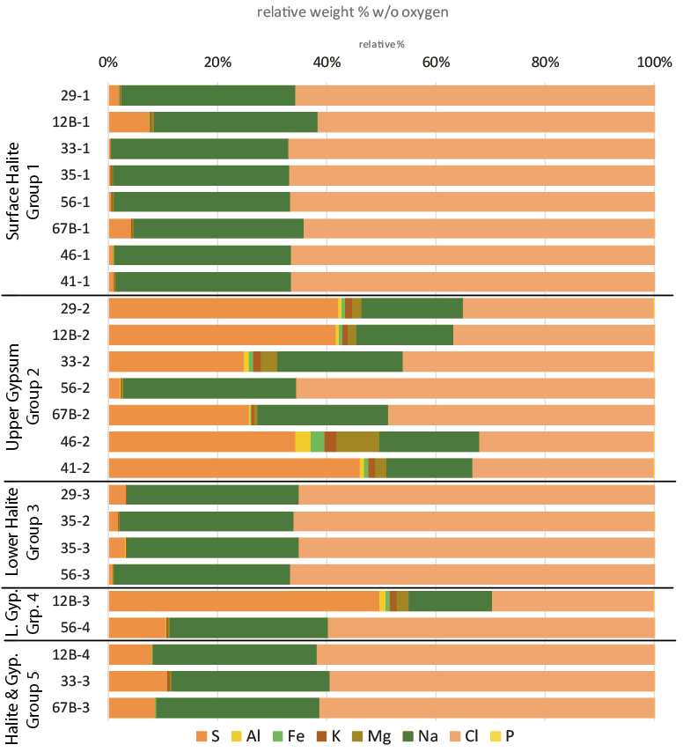

**Supplemental Figure 5:** Elemental data for each sample site and group reported as relative weight percent for the whole sample.

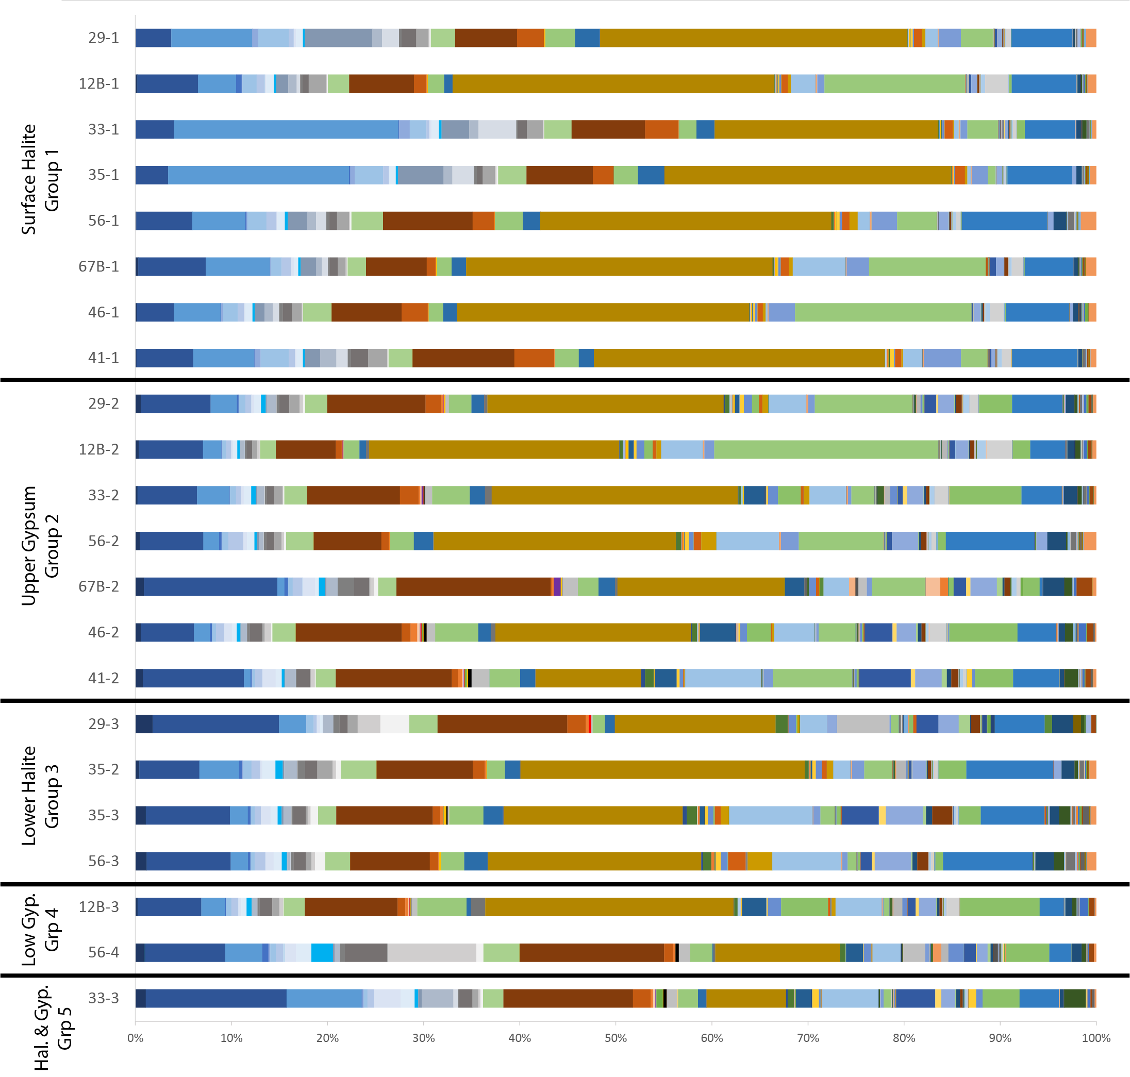

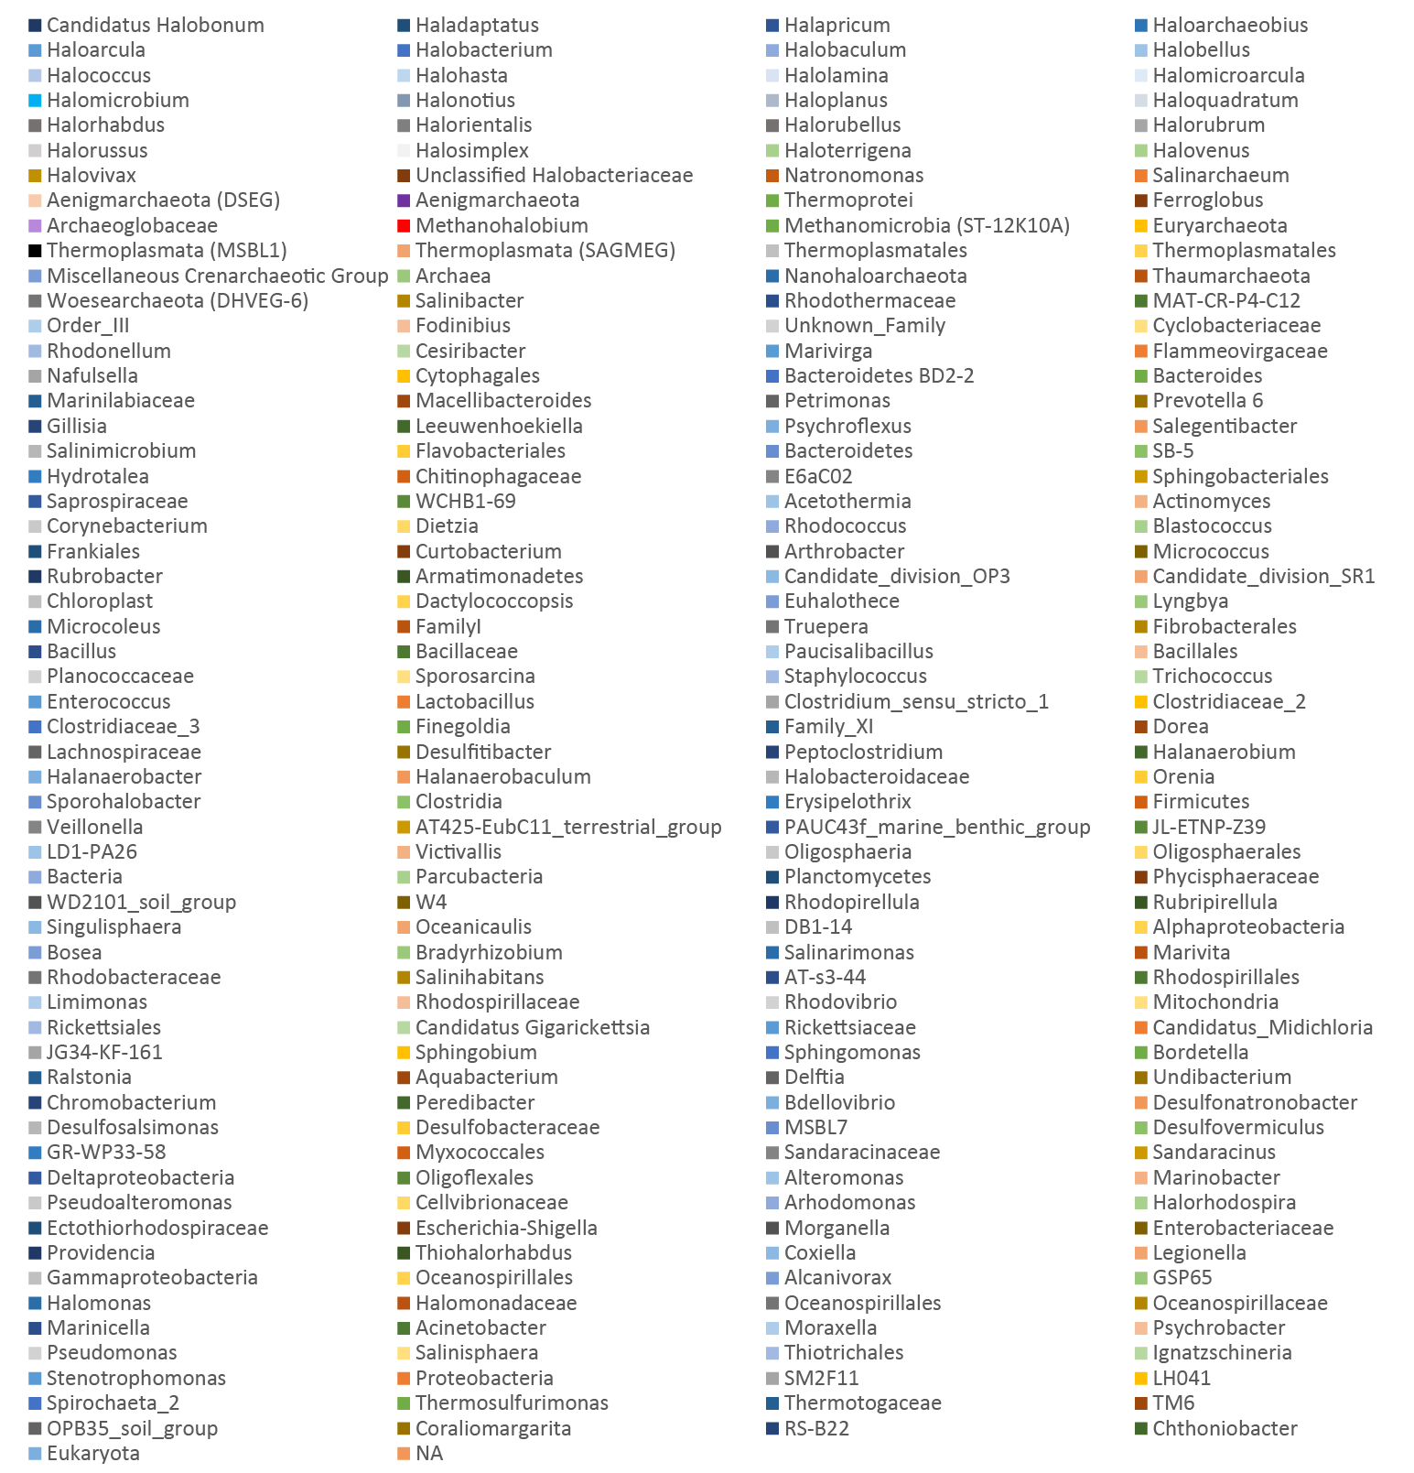

**Supplemental Figure 6:** Taxonomy of all ASVs from bacterial dataset in all samples.

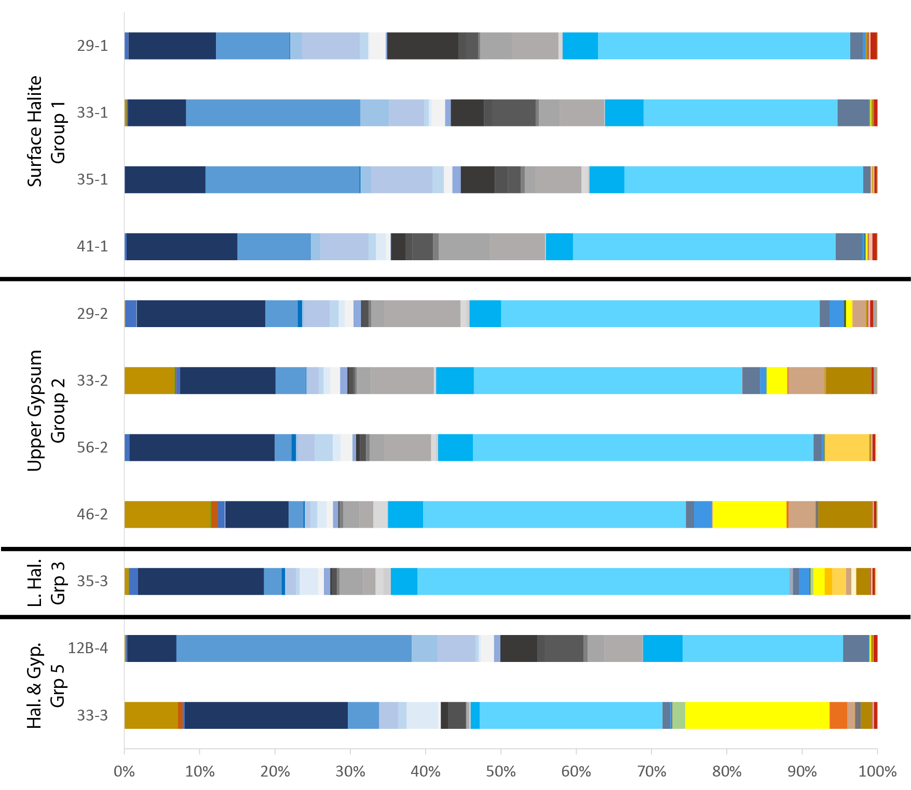  
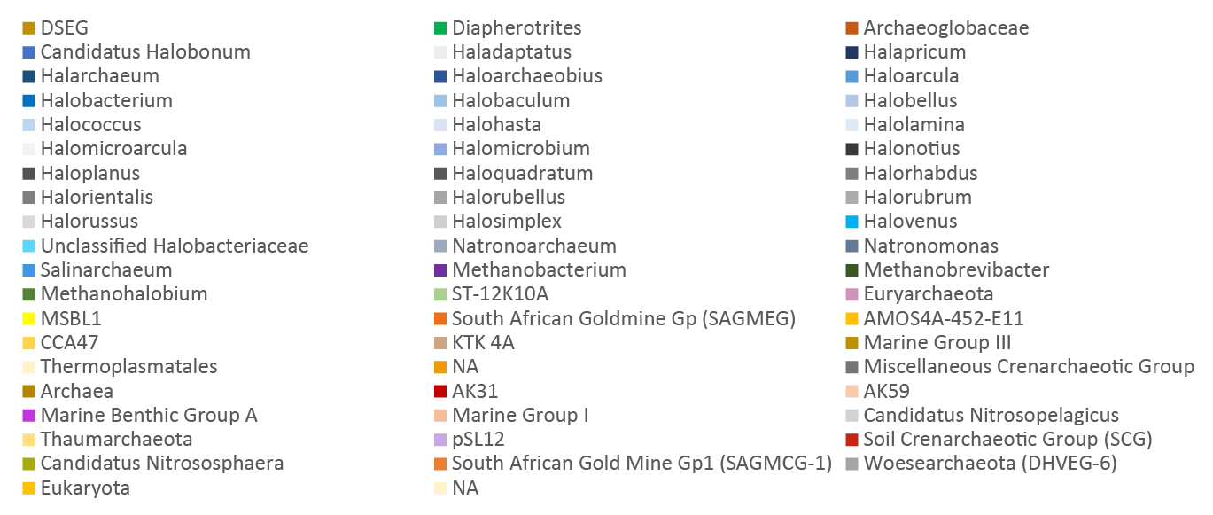  
**Supplemental Figure 7:** Taxonomy of all ASVs from archaeal dataset in all samples.

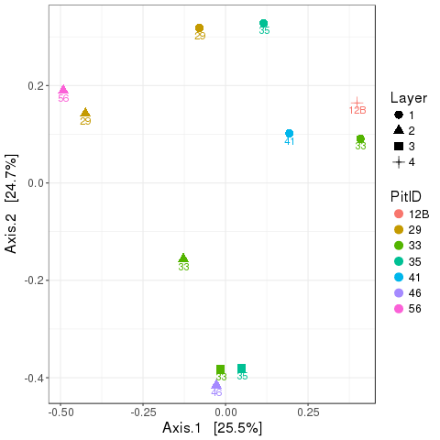

**Supplemental Figure 8:** Multivariate analysis of archeal dataset created in phyloseq using the Bray-Curtis beta diversity index.

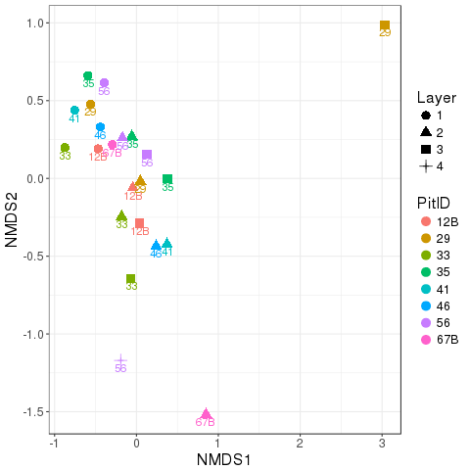

**Supplemental Figure 9:** Multivariate analysis of bacterial dataset created in phyloseq using the Bray-Curtis beta diversity index.

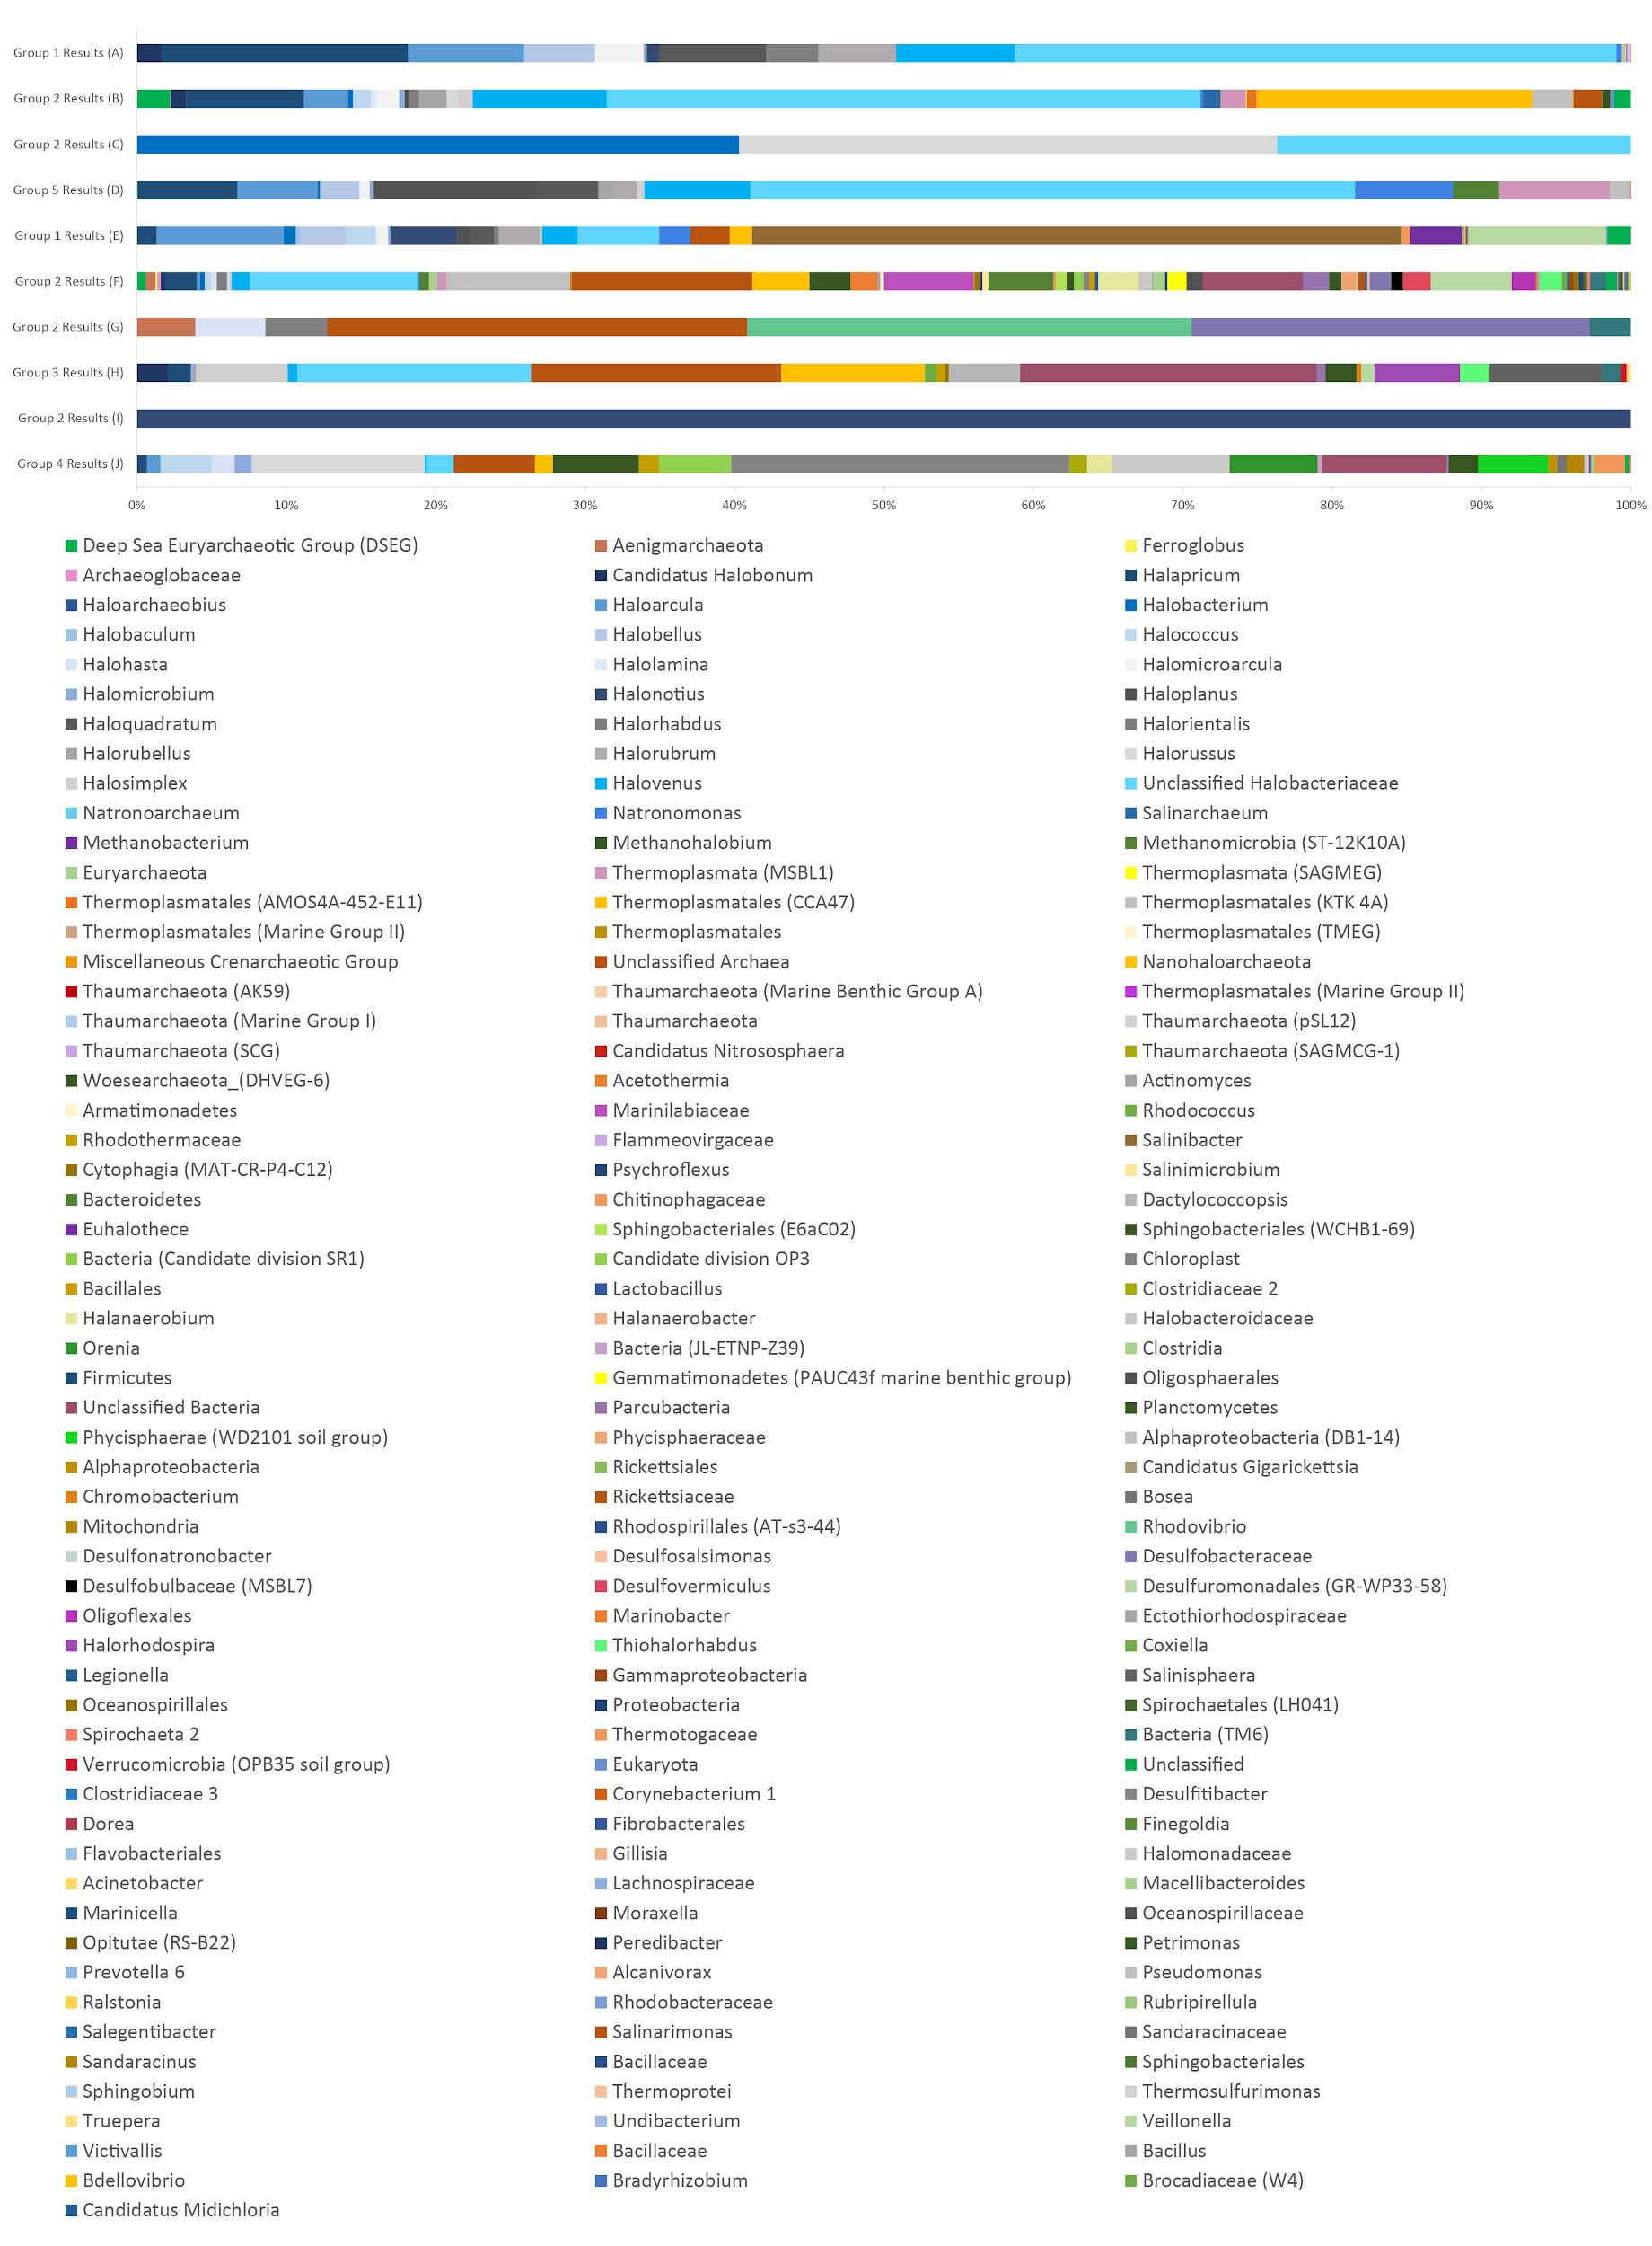  
**Supplemental Figure 10:** ASVs with greater relative abundance in each group as determined by differential abundance (EdgeR) comparisons noted in Figure 1

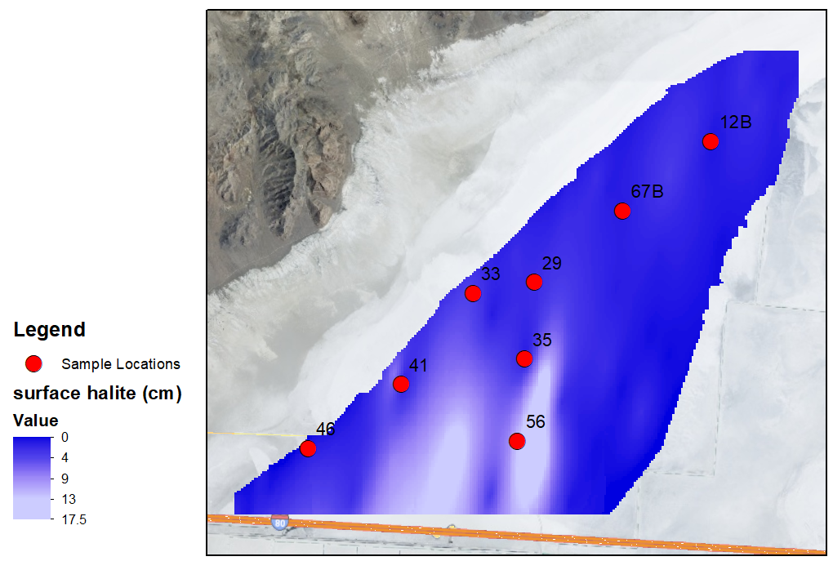

**Supplemental Figure 11:** Location of sampling sites and surface halite thickness across the Bonneville Salt Flats time of sampling (Bowen et al., 2018 - geofluids paper). Note: this surface halite classification, while similar to Group 1, is not equivalent, due to the coarser vertical resolution of Bowen, 2018.